**PATIENT DATABASE WEB APPLICATION**

This system should help the hospital database manager to maintain complete profile of

Patients who visit to the particular hospital this database application is convenient to easily retrieve the patient information in the database application there are two module those are admin database manager. Admin can be able to register himself and login to the application and can check view the complete database and also can be able to add the database managers to take control on handling the patient profile that can be branch/department wise and also manage DM’s based on requirements

DM’s should be able to login to database application with the username and password provided by the admin and theses DM’s should be able to add or edit patient records based on an information from the patients and the doctors feedback and also DM’s should be able to retrieve the patient reports upon the search, and admission details if patient is admitted and also the billing details for reference

MODULE: ADMIN

**Register**:

**User Story:**

Given I open Register

When I login to the Register page as an admin

Then I should be able to register by my first name, last name, employee id, email so that I can login to application

**Scope(Expected output)**

* Build a register page

**Task**

Front end Test cases: Put sign up option in homepage along with username and password

**Login:**

**User Story:**

Given I open login page

When I login to the database application by giving my username and password after successful registration

Then I should be able to get inside the application and view the home page where I can see patient’s data along with the menu options like Add and manage database managers to handle the database

**Scope: (expected Output)**

* Build a login page
* Admin validation
* Admin should be able to change the password
* It should work in all browsers

**Pre-Condition:**

* Admin should have registered himself in Database application

**Acceptance Criteria:**

Scenario 1: Successful login

When I access login page and give my valid credentials and click on sign in then my login should be successful

Scenario 2: Unsuccessful login

When I access login page and give invalid credentials and click on sign in then I should get an error as “ login failed, invalid username and password”

Scenario 3: Reset Password

When I’m on login page and click on forgot password then I should receive a link to my email and should be able to set new password clicking on the link

**Task**

Functional Test cases: Verify user name and password , forgot password , and remember me options

**Subtask**

Performance test: verify the time taken to login with valid username and password

Visibility test: verify if there is cancel button to erase the entered test

**Add Database Manager:**

**User Story:**

Given I open Add DM page

When I open the Add DM page upon successful login

Then I should be able add the database managers on a branch wise/department wise along with their complete personal and professional details and should be able to raise login credentials to them

**Scope: (expected Output)**

* Build a Add Data Managers’ page

**Task**

Backend test cases: validate data in database

**Manage Database Manager:**

**User Story:**

Given I open manage DM page

When I click on the manage DM page after adding them successfully

Then I should be able to view the complete details of them and I should be able to update their details and add or delete the DM’s based on business requirements

**Scope: (expected Output)**

* Build a Manage Data Managers’ page

Module: DATABASE MANAGERS

**Login:**

**User Story:**

Given I open login page

When I login to the database application by giving my username and password

Then I should be able to get inside the application and view the home page where I can see patient’s data along with the menu options like Add/edit Patient, Patient records, admission details and billing details

**Scope: (expected Output)**

* Build a login page
* Staff validation
* Staff should be able to change the password
* It should work in all browsers

**Pre-Condition:**

* Admin should have registered DMs profile in Database application

**Acceptance Criteria:**

Scenario 1: Successful login

When I access login page and give my valid credentials and click on sign in then my login should be successful

Scenario 2: Unsuccessful login

When I access login page and give invalid credentials and click on sign in then I should get an error as “ login failed, invalid username and password”

Scenario 3: Reset Password

When I’m on login page and click on forgot password then I should receive a link to my email and should be able to set new password clicking on the link

**Task**

Functional Test cases: Verify user name and password , forgot password , and remember me options

**Subtask**

Performance test: verify the time taken to login with valid username and password

Visibility test: verify if there is cancel button to erase the entered test

**Search:**

**User story:**

Given Search page

When I click on the search option and give any patient details

Then I should be able to view the related results of that details

**Scope: (expected Output)**

* + Build a search page
  + Patient validation

**Pre-Condition:**

* Patient details should have added in database

**Acceptance Criteria:**

Scenario 1: successful search

When I give valid Patient id/details and click on search then I should access the matching results

Scenario 2: Unsuccessful search

When I give invalid patient details and click on search then I should get message as “No Results Found”

**Add/Edit Patient:**

**User Story:**

Given Add/Edit patient menu

When I click on add patient on a new registration request or on first visit

Then I should be able to add complete patient details such as patient name , mobile number, gender, email, address, date,

When clicking on edit option upon searching the patient details

then I should be able to edit the same as per the proper request

**Scope( expected output)**

* + - Build a menu page with add patient and update patient info
    - Patient validation

**Task**

Backend test cases: validate data in database

**Patient Reports:**

**User Story:**

Given Patient Reports

When I click on patient Reports option on a new request

Then I should be able to View the patient’s previous test reports along with lab technician and suggested doctors details and also I should have access to upload the new test reports

**Scope( expected output):**

* Build a menu page with add Patient reports info

**Task**

Backend test cases: validate data in database

**Admission:**

**User Story:**

Given Admission Menu

When I click on Admission option

Then I should be able to View the patient’s admission details such as admitted date, chosen ward, patient Id, Diagnosis, Specialist treated and discharged date

**Scope(Expected output)**

Build a Admission menu page

**Billing:**

**User Story:**

Given Billing option

When I click on billing menu option

Then I should be able to view the patient previous bills if any with the details such as bill id, bill date bill amount and consulted doctor and also I should be able to generate a new bills when required

**Scope( expected Output)**

* Build a Billing menu option

Screenshots before arranging sprints

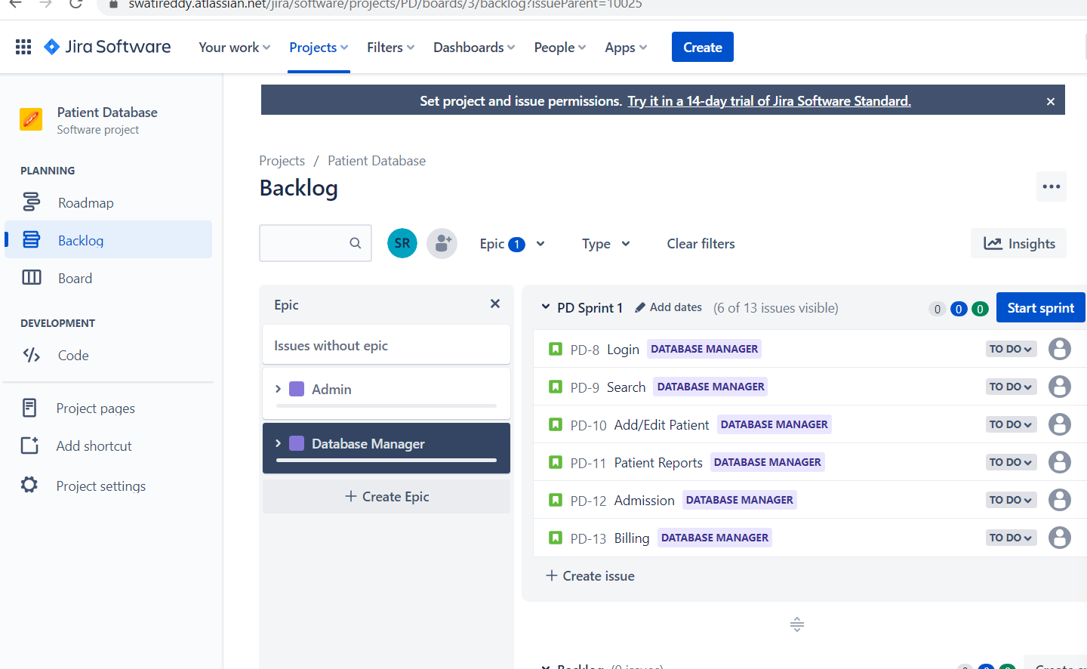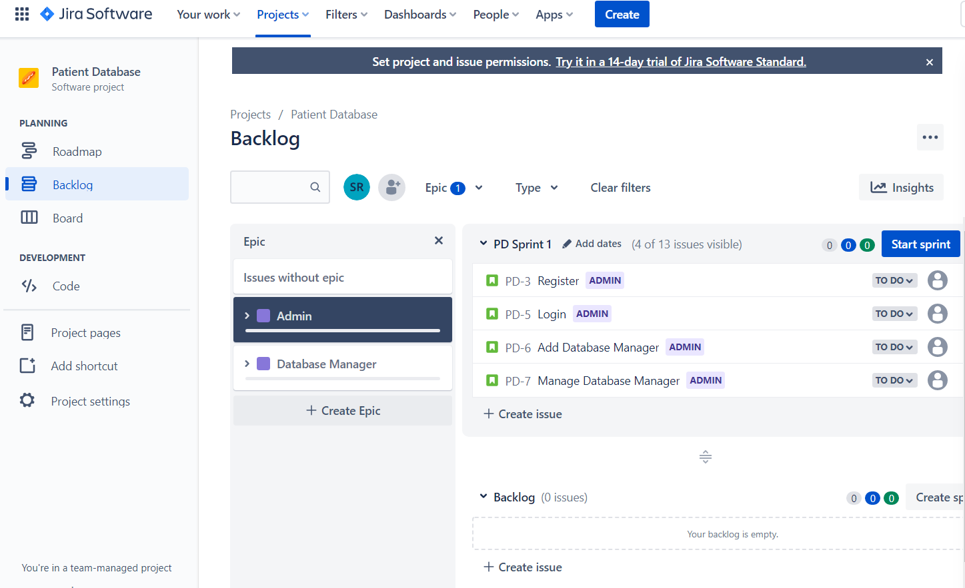

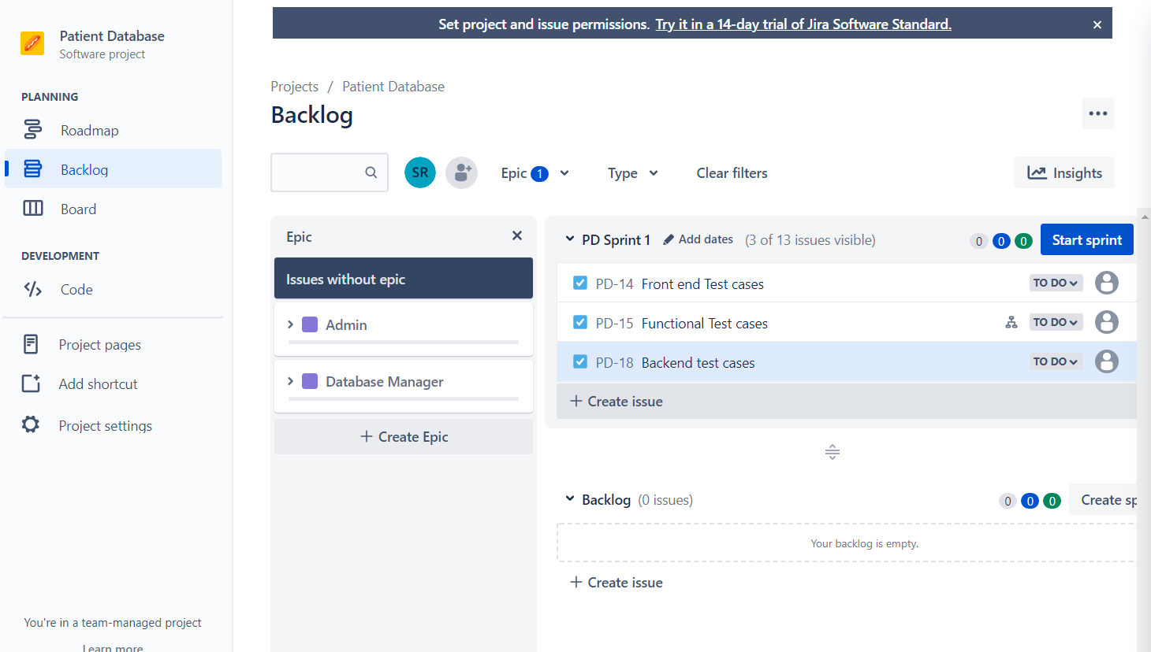

Screenshots after arranging sprints along with the dates

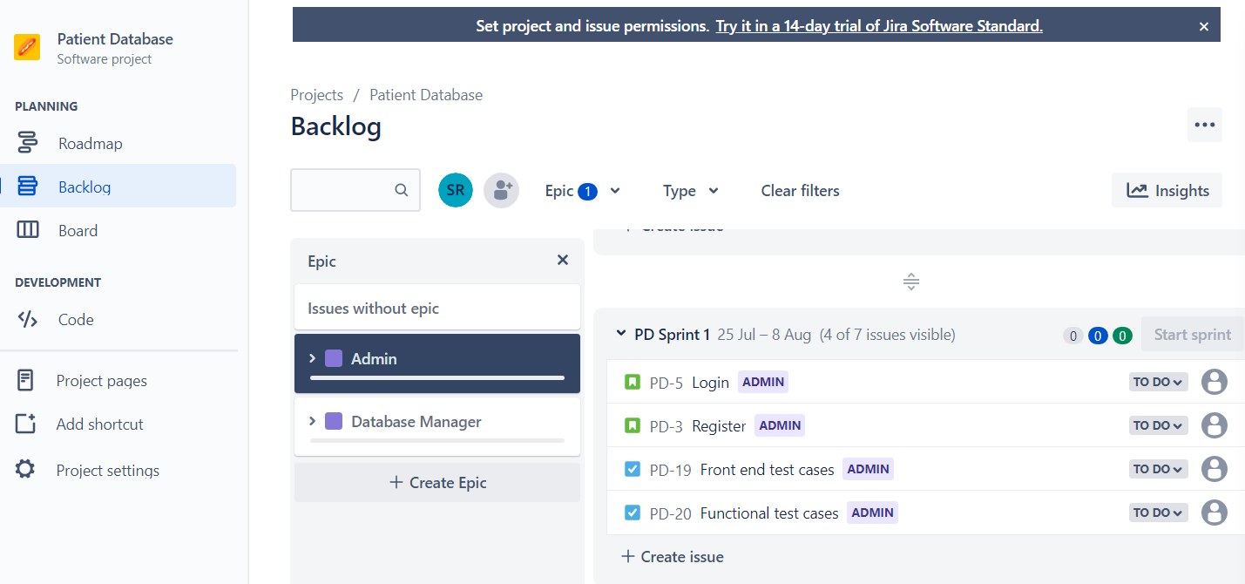

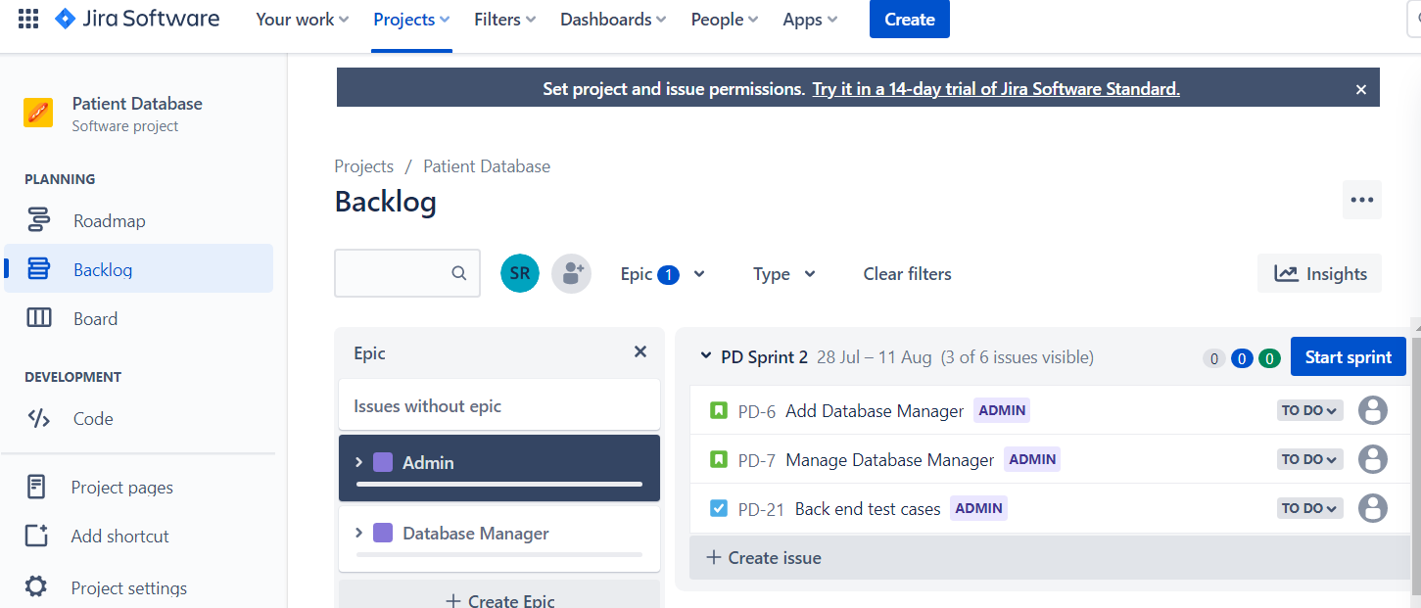

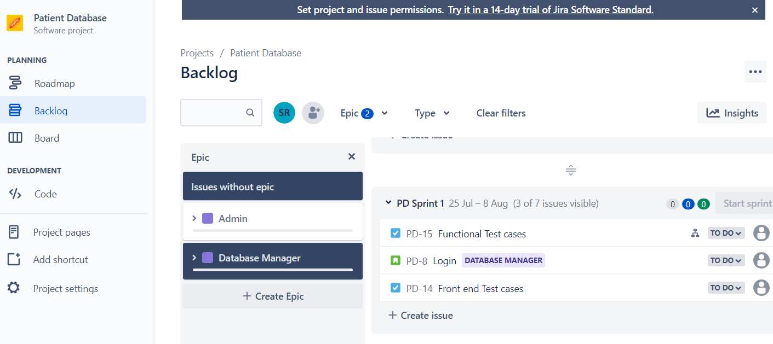

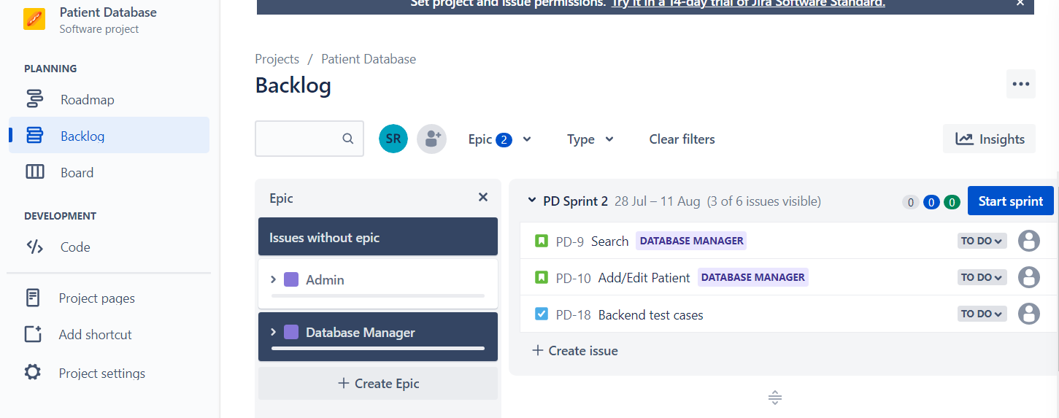

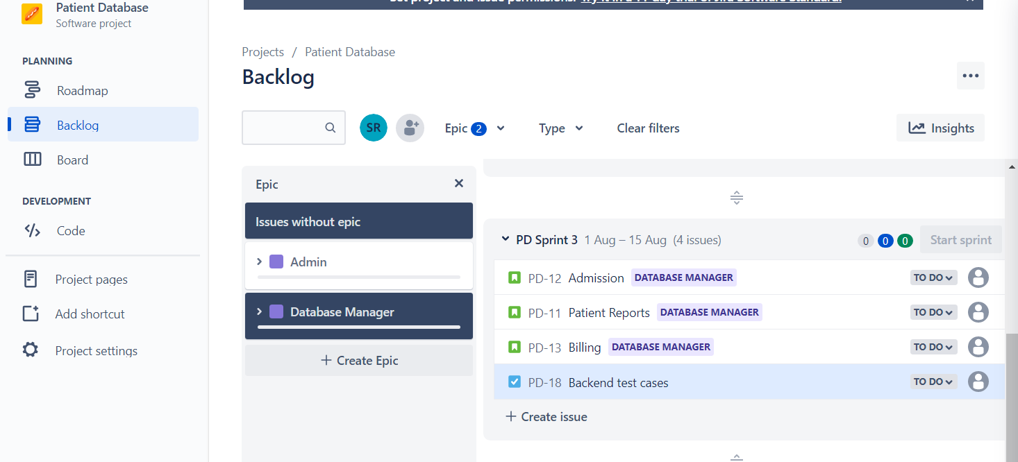

Confluence Connect

